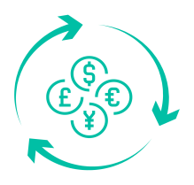

CurrenSee

# User Guide

**Preared by:**

[Aptech Students]

***CurrenSee***

|  |  |  |
| --- | --- | --- |
| **Supervisor.** | Sir Imran Ali | |
| **Batch.** | 2202C2 | |
| **Serial No.** | **Enrollment Number** | **Student Name** |
| 1. | Student 1365824 | Atya |
| 2. | Student1362560 | MUHAMMAD BILAL |
| 3. | Student1365428 | Azhar Shah |
| 4. | Student1365416 | Abdul Mughni Siddiqui |

User Guide for CurrenSee  
(Currency Conerter App)

### Introduction

Welcome to the User guide for the ABC Finance Ltd. Currency Converter App. This document provides a comprehensive overview of the app's architecture, setup instructions, features, and functionalities to assist developers in understanding and contributing to the project

### Project Overview

The Currency Converter App name as Curren is a Flutter-based mobile application for Android that provides users with real-time currency conversion rates. The app supports multiple currencies and allows users to quickly and easily perform conversions between them.

**Splash screen**

**1.Splash Screen.dart**

A splash screen is a launch screen, start screen, or boot screen, which is a

graphical control element containing the image, logo, and current version the

software. It is the first screen of the app that displays whenever the

application is loading.



**2.Login**

A login page specifies the login URL in a web application that users must pass through to get to the authenticated URLs at the heart of the application.

Authenticated URLs are URLs that become accessible to users only

after they successfully log in to the login URL.

|  |  |
| --- | --- |
| login | login validation |

3.Signup

A signup page (also known as a registration page) enables users and

organizations to independently register and gain access to your system

It is common to have multiple signup pages depending on the types of

people and organizations you want to register.

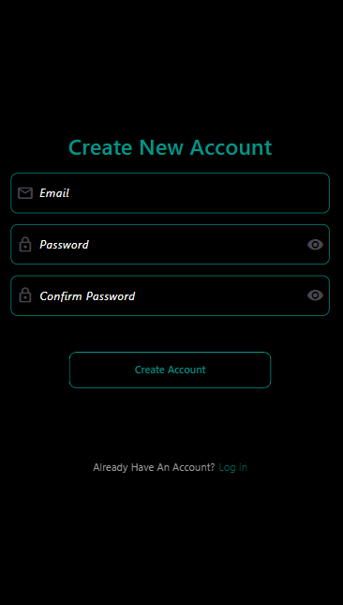

**4.Currency Converter**

A Flutter currency convertor app designed to provide users a facility to

exchange the currencies rates. It uses an API to display the exchanged data.These currency converters can be readily found online and can quickly convert the value of one currency to another, such as euros to pounds or dollars to

euros.

|  |  |  |
| --- | --- | --- |
| Conversion | from drop | todrop |

**5.Conversion History**

A Flutter currency convertor app designed to provide users a facility to

exchange the currencies rates and save conversion history . It uses an API to display the exchanged data. And user can also delete and undo their conversiions

|  |  |
| --- | --- |
| history | slide to delete |

**6.Rate Alerts**

Exchange rate alerts notify you when the currency exchange rate

reaches a specific threshold you set. Imagine setting an alert for

when the Pakistani Rupee strengthens against the Euro

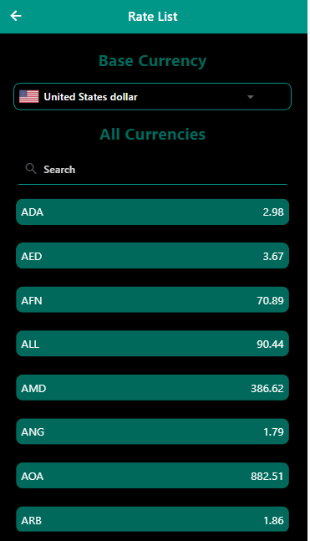

**7. User preferences**

In Flutter, user preferences control the behavior and appearances of

your web application. The user preferences that you set apply to the

user interface for only your session, and not to user interface for the sessions of other users.

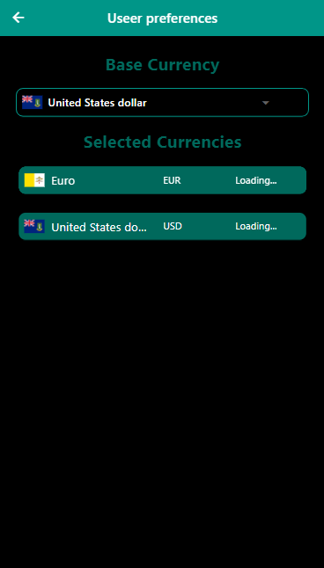

**8.User Support and Help center**

An FAQ page (short for Frequently Asked Question page) is a part of

your website that provides answers to common questions, assuages

concerns, and overcomes objections.

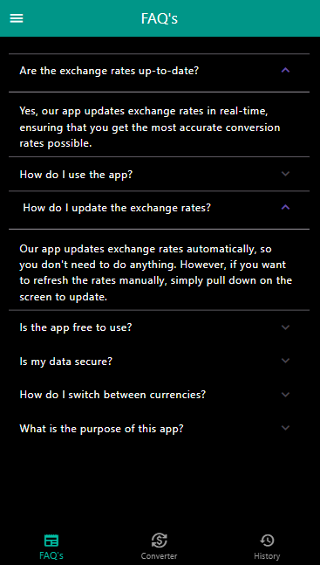

**10.User Feedback**

Form is used by customer to give feedback form or to ask their query.

The field in feedback form are entered with the following requirement

.

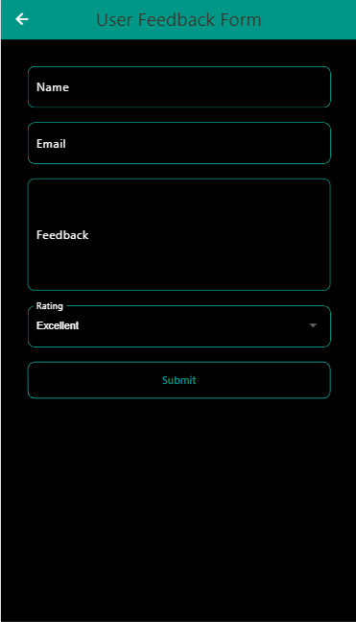

**Thankyou.**